Inverse Transformation

Definition
# Source: AI Source: Provided by: [Data Path: Persons Table -> ID Column: 1, Name_En Column: Motasem Essam] -> From: [ChatGPT] on [7/25/2026]
An Inverse Transformation is a geometric transformation that reverses the effect of another transformation, returning every transformed point or figure to its original position.
If a transformation is $T$, its inverse is written:
$$T^{-1}$$
and satisfies:
$$T^{-1}\left(T\left(P\right)\right)=P$$
and:
$$T\left(T^{-1}\left(P\right)\right)=P$$
for every point $P$in the appropriate domain.
Simple Definition
An inverse transformation undoes another transformation and returns the transformed figure to its original position.

Main Classification
# Source: AI Source: Provided by: [Data Path: Persons Table -> ID Column: 1, Name_En Column: Motasem Essam] -> From: [ChatGPT] on [7/25/2026]
A practical classification of inverse transformations is:
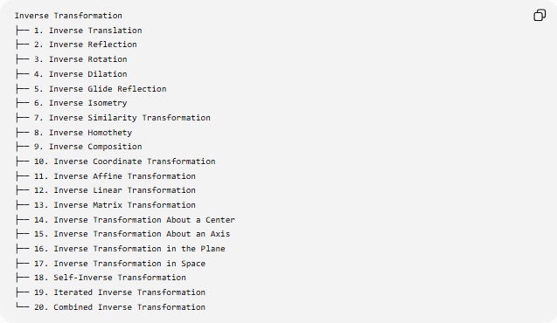
Inverse Transformation
├── 1. Inverse Translation
├── 2. Inverse Reflection
├── 3. Inverse Rotation
├── 4. Inverse Dilation
├── 5. Inverse Glide Reflection
├── 6. Inverse Isometry
├── 7. Inverse Similarity Transformation
├── 8. Inverse Homothety
├── 9. Inverse Composition
├── 10. Inverse Coordinate Transformation
├── 11. Inverse Affine Transformation
├── 12. Inverse Linear Transformation
├── 13. Inverse Matrix Transformation
├── 14. Inverse Transformation About a Center
├── 15. Inverse Transformation About an Axis
├── 16. Inverse Transformation in the Plane
├── 17. Inverse Transformation in Space
├── 18. Self-Inverse Transformation
├── 19. Iterated Inverse Transformation
└── 20. Combined Inverse Transformation
Some of these are specific inverse operations, while others describe the mathematical setting or structure in which an inverse is used.

1. Inverse Translation
# Source: AI Source: Provided by: [Data Path: Persons Table -> ID Column: 1, Name_En Column: Motasem Essam] -> From: [ChatGPT] on [7/25/2026]
A translation moves every point by the same displacement vector.
If:
$$T\left(x , y\right)=\left(x , +ay+b\right)$$
then the inverse translation is:
$$T^{-1}\left(x , y\right)=\left(x , -ay-b\right)$$
Example
Original transformation:
$$T\left(x , y\right)=\left(x , +5y-2\right)$$
For:
$$P=\left(2 , 4\right)$$
we obtain:
$$P^{'}=\left(7 , 2\right)$$
The inverse gives:
$$T^{-1}\left(7 , 2\right)=\left(7 , -52+2\right) \\ \boxed{P=\left(2 , 4\right)}$$
So the inverse translation moves the figure 5 units left and 2 units up.

2. Inverse Reflection
# Source: AI Source: Provided by: [Data Path: Persons Table -> ID Column: 1, Name_En Column: Motasem Essam] -> From: [ChatGPT] on [7/25/2026]
A reflection is its own inverse.
For example, reflection across the $x$-axis is:
$$T\left(x , y\right)=\left(x , -y\right)$$
Applying the same reflection again:
$$T\left(T\left(x , y\right)\right)=\left(x , y\right)$$
Therefore:
$$\boxed{T^{-1}=T}$$
Example
$$P=\left(3 , 5\right)$$
Reflection across the $x$-axis:
$$P^{'}=\left(3 , -5\right)$$
Reflect again:
$$\left(3 , -5\right)→\left(3 , 5\right)$$
Thus the original point is recovered.

3. Inverse Rotation
# Source: AI Source: Provided by: [Data Path: Persons Table -> ID Column: 1, Name_En Column: Motasem Essam] -> From: [ChatGPT] on [7/25/2026]
The inverse of a rotation by angle $θ$is a rotation by:
$$-θ$$
about the same center.
Thus:
$$R_{θ}^{-1}=R_{-θ}$$
Example
A ${90}^{∘}$counterclockwise rotation has inverse:
$${90}^{∘}\text{ clockwise}$$
or:
$$R_{{90}^{∘}}^{-1}=R_{-{90}^{∘}}$$
For a rotation about the origin:
$$\left(x , y\right)→\left(- , yx\right)$$
The inverse is:
$$\left(x , y\right)→\left(y , -x\right)$$
Example
$$\left(2 , 3\right)→\left(- , 32\right)$$
Then:
$$\left(- , 32\right)→\left(2 , 3\right)$$

4. Inverse Dilation
# Source: AI Source: Provided by: [Data Path: Persons Table -> ID Column: 1, Name_En Column: Motasem Essam] -> From: [ChatGPT] on [7/25/2026]
A dilation changes the size of a figure using a scale factor $k$.
Its inverse uses:
$$\boxed{\frac{1}{k}}$$
provided:
$$k≠0$$
If:
$$D_{k}$$
is a dilation with scale factor $k$, then:
$$D_{k}^{-1}=D_{\frac{1}{k}}$$
Example
Suppose:
$$k=3$$
Then:
$$D_{3}^{-1}=D_{\frac{1}{3}}$$
A point:
$$P=\left(2 , 4\right)$$
becomes:
$$P^{'}=\left(6 , 12\right)$$
Applying the inverse:
$$\left(6 , 12\right)→\left(2 , 4\right)$$

5. Inverse Glide Reflection
# Source: AI Source: Provided by: [Data Path: Persons Table -> ID Column: 1, Name_En Column: Motasem Essam] -> From: [ChatGPT] on [7/25/2026]
A glide reflection consists of a reflection followed by a translation parallel to the reflection axis.
If:
$$G=T_{v}∘R_{l}$$
then the inverse is:
$$G^{-1}=R_{l}^{-1}∘T_{v}^{-1}$$
Since reflection is self-inverse:
$$R_{l}^{-1}=R_{l}$$
Therefore:
$$\boxed{G^{-1}=R_{l}∘T_{-v}}$$
The order is important because composition generally does not commute.

6. Inverse Isometry
# Source: AI Source: Provided by: [Data Path: Persons Table -> ID Column: 1, Name_En Column: Motasem Essam] -> From: [ChatGPT] on [7/25/2026]
An isometry preserves distances.
Examples include:
- Translation
- Rotation
- Reflection
- Glide reflection
If $T$is an isometry, then its inverse is also an isometry:
$$d\left(P , Q\right)=d\left(T , \left(P\right)T\left(Q\right)\right)$$
and:
$$d\left(P^{'} , Q^{'}\right)=d\left(P , Q\right)$$
Example
A rotation preserves the distance between every pair of points. Its inverse rotation also preserves those distances.
Therefore:
$$\boxed{\text{Inverse of an isometry is an isometry}}$$

7. Inverse Similarity Transformation
# Source: AI Source: Provided by: [Data Path: Persons Table -> ID Column: 1, Name_En Column: Motasem Essam] -> From: [ChatGPT] on [7/25/2026]
A similarity transformation preserves shape while multiplying lengths by a scale factor $k$.
Its inverse uses:
$$\frac{1}{k}$$
Therefore:
$$S_{k}^{-1}=S_{\frac{1}{k}}$$
Example
If a similarity transformation doubles every length:
$$k=2$$
then its inverse reduces every length by:
$$\frac{1}{2}$$
So a side of length $10$becomes:
$$10→20→10$$

8. Inverse Homothety
# Source: AI Source: Provided by: [Data Path: Persons Table -> ID Column: 1, Name_En Column: Motasem Essam] -> From: [ChatGPT] on [7/25/2026]
A homothety is a dilation centered at a fixed point.
If its scale factor is $k$, the inverse homothety has:
$$k^{-1}=\frac{1}{k}$$
Example
For:
$$k=4$$
the inverse has:
$$k^{-1}=\frac{1}{4}$$
Thus:
$$H_{4}^{-1}=H_{\frac{1}{4}}$$

9. Inverse Composition
# Source: AI Source: Provided by: [Data Path: Persons Table -> ID Column: 1, Name_En Column: Motasem Essam] -> From: [ChatGPT] on [7/25/2026]
Suppose several transformations are applied in sequence:
$$T=T_{3}∘T_{2}∘T_{1}$$
The inverse is applied in reverse order:
$$\boxed{T^{-1}=T_{1}^{-1}∘T_{2}^{-1}∘T_{3}^{-1}}$$
Example
Suppose:
- Translate
- Rotate
- Reflect
Then the inverse must:
- Undo the reflection
- Undo the rotation
- Undo the translation
This is one of the most important rules for inverse transformations.

10. Inverse Coordinate Transformation
# Source: AI Source: Provided by: [Data Path: Persons Table -> ID Column: 1, Name_En Column: Motasem Essam] -> From: [ChatGPT] on [7/25/2026]
A coordinate transformation changes the coordinates of points.
For example:
$$T\left(x , y\right)=\left(x , +4y-3\right)$$
The inverse is obtained by solving for $x,y$.
Let:
$$x^{'}=x+4 \\ y^{'}=y-3$$
Therefore:
$$x=x^{'}-4 \\ y=y^{'}+3$$
Thus:
$$\boxed{T^{-1}\left(x , y\right)=\left(x , -4y+3\right)}$$

11. Inverse Affine Transformation
# Source: AI Source: Provided by: [Data Path: Persons Table -> ID Column: 1, Name_En Column: Motasem Essam] -> From: [ChatGPT] on [7/25/2026]
An affine transformation can be written:
$$x^{'}=Ax+b$$
where $A$is an invertible matrix.
Its inverse is:
$$\boxed{x=A^{-1}\left(x^{'}-b\right)}$$
Therefore:
$$T^{-1}\left(x\right)=A^{-1}\left(x-b\right)$$
provided:
$$det⁡\left(A\right)≠0$$
Example
Suppose:
$$x^{'}=\left(\begin{matrix}2 & 0 \\ 0 & 3\end{matrix}\right)x$$
Then:
$$A^{-1}=\left(\begin{matrix}\frac{1}{2} & 0 \\ 0 & \frac{1}{3}\end{matrix}\right)$$
So the inverse scales the coordinates by:
$$\left(\frac{1}{2} , \frac{1}{3}\right)$$

12. Inverse Linear Transformation
# Source: AI Source: Provided by: [Data Path: Persons Table -> ID Column: 1, Name_En Column: Motasem Essam] -> From: [ChatGPT] on [7/25/2026]
A linear transformation has the form:
$$T\left(x\right)=Ax$$
If $A$is invertible:
$$\boxed{T^{-1}\left(x\right)=A^{-1}x}$$
The transformation has an inverse exactly when the matrix is invertible.
For a square matrix:
$$det⁡\left(A\right)≠0$$
is the condition for invertibility.

13. Inverse Matrix Transformation
# Source: AI Source: Provided by: [Data Path: Persons Table -> ID Column: 1, Name_En Column: Motasem Essam] -> From: [ChatGPT] on [7/25/2026]
If a geometric transformation is represented by matrix $A$, its inverse is represented by:
$$A^{-1}$$
such that:
$$AA^{-1}=A^{-1}A=I$$
where $I$is the identity matrix.
Example
For a ${90}^{∘}$counterclockwise rotation:
$$A=\left(\begin{matrix}0 & -1 \\ 1 & 0\end{matrix}\right)$$
Its inverse is:
$$A^{-1}=\left(\begin{matrix}0 & 1 \\ -1 & 0\end{matrix}\right)$$
which represents a ${90}^{∘}$clockwise rotation.

14. Inverse Transformation About a Center
# Source: AI Source: Provided by: [Data Path: Persons Table -> ID Column: 1, Name_En Column: Motasem Essam] -> From: [ChatGPT] on [7/25/2026]
Some transformations are defined relative to a fixed center.
For example, a rotation around $O$by $θ$has inverse:
$$R_{O,θ}^{-1}=R_{O,-θ}$$
A dilation centered at $O$with factor $k$has inverse:
$$D_{O,k}^{-1}=D_{O,1/k}$$
The center remains the same, while the transformation is reversed.

15. Inverse Transformation About an Axis
# Source: AI Source: Provided by: [Data Path: Persons Table -> ID Column: 1, Name_En Column: Motasem Essam] -> From: [ChatGPT] on [7/25/2026]
Reflection across an axis is self-inverse.
If:
$$R_{l}$$
is reflection across line $l$, then:
$$\boxed{R_{l}^{-1}=R_{l}}$$
Example
Reflection across:
$$y=x$$
has coordinate rule:
$$\left(x , y\right)→\left(y , x\right)$$
Applying it twice:
$$\left(x , y\right)→\left(y , x\right)→\left(x , y\right)$$

16. Inverse Transformation in the Plane
# Source: AI Source: Provided by: [Data Path: Persons Table -> ID Column: 1, Name_En Column: Motasem Essam] -> From: [ChatGPT] on [7/25/2026]
In two-dimensional geometry, an inverse transformation maps transformed points back to their original points.
For:
$$T:R^{2}→R^{2}$$
the inverse is:
$$T^{-1}:R^{2}→R^{2}$$
such that:
$$T^{-1}∘T=I$$
and:
$$T∘T^{-1}=I$$
where $I$is the identity transformation.

17. Inverse Transformation in Space
# Source: AI Source: Provided by: [Data Path: Persons Table -> ID Column: 1, Name_En Column: Motasem Essam] -> From: [ChatGPT] on [7/25/2026]
The same concept applies in three dimensions.
For:
$$T:R^{3}→R^{3}$$
the inverse satisfies:
$$T^{-1}\left(T\left(P\right)\right)=P$$
Example
A translation:
$$\left(x , y , z\right)→\left(x , + , 2y-3z+5\right)$$
has inverse:
$$\left(x , y , z\right)→\left(x , - , 2y+3z-5\right)$$

18. Self-Inverse Transformation
# Source: AI Source: Provided by: [Data Path: Persons Table -> ID Column: 1, Name_En Column: Motasem Essam] -> From: [ChatGPT] on [7/25/2026]
A transformation is self-inverse if it is its own inverse.
Therefore:
$$\boxed{T^{-1}=T}$$
Equivalently:
$$T∘T=I$$
Examples
Reflection
$$R_{l}^{-1}=R_{l}$$
${180}^{∘}$Rotation
$$R_{{180}^{∘}}^{-1}=R_{-{180}^{∘}}$$
But:
$$-{180}^{∘}≡{180}^{∘}$$
so:
$$\boxed{R_{{180}^{∘}}^{-1}=R_{{180}^{∘}}}$$

19. Iterated Inverse Transformation
# Source: AI Source: Provided by: [Data Path: Persons Table -> ID Column: 1, Name_En Column: Motasem Essam] -> From: [ChatGPT] on [7/25/2026]
An inverse transformation can be applied repeatedly.
If:
$$P^{'}=T\left(P\right)$$
then:
$$P=T^{-1}\left(P^{'}\right)$$
Applying the inverse again gives another transformed position:
$$T^{-1}\left(P\right)$$
Example
For a translation:
$$T\left(x , y\right)=\left(x , +2y\right)$$
the inverse is:
$$T^{-1}\left(x , y\right)=\left(x , -2y\right)$$
Repeated inverse applications move the point:
$$\left(x , y\right)→\left(x , -2y\right)→\left(x , -4y\right)→\left(x , -6y\right)$$

20. Combined Inverse Transformation
# Source: AI Source: Provided by: [Data Path: Persons Table -> ID Column: 1, Name_En Column: Motasem Essam] -> From: [ChatGPT] on [7/25/2026]
A transformation can combine several different transformations.
For example:
$$T=R∘D∘T_{r}$$
where:
- $T_{r}$= translation
- $D$= dilation
- $R$= rotation
Then:
$$\boxed{T^{-1}=T_{r}^{-1}∘D^{-1}∘R^{-1}}$$
Each component is reversed, and the order is reversed.

General Rule for Finding an Inverse
# Source: AI Source: Provided by: [Data Path: Persons Table -> ID Column: 1, Name_En Column: Motasem Essam] -> From: [ChatGPT] on [7/25/2026]
A useful procedure is:
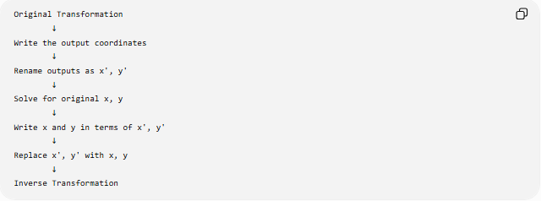
Original Transformation
↓
Write the output coordinates
↓
Rename outputs as x', y'
↓
Solve for original x, y
↓
Write x and y in terms of x', y'
↓
Replace x', y' with x, y
↓
Inverse Transformation
Example
Given:
$$T\left(x , y\right)=\left(2 , x+13y-2\right)$$
Let:
$$x^{'}=2x+1 \\ y^{'}=3y-2$$
Solve:
$$x=\frac{x^{'}-1}{2} \\ y=\frac{y^{'}+2}{3}$$
Therefore:
$$\boxed{T^{-1}\left(x , y\right)=\left(\frac{x-1}{2} , \frac{y+2}{3}\right)}$$

Important Properties

Property 1 — Undoing the Transformation
# Source: AI Source: Provided by: [Data Path: Persons Table -> ID Column: 1, Name_En Column: Motasem Essam] -> From: [ChatGPT] on [7/25/2026]
$$T^{-1}\left(T\left(P\right)\right)=P$$
The inverse returns a transformed point to its original position.

Property 2 — Identity
# Source: AI Source: Provided by: [Data Path: Persons Table -> ID Column: 1, Name_En Column: Motasem Essam] -> From: [ChatGPT] on [7/25/2026]
$$T^{-1}∘T=I$$
and:
$$T∘T^{-1}=I$$

Property 3 — Uniqueness
# Source: AI Source: Provided by: [Data Path: Persons Table -> ID Column: 1, Name_En Column: Motasem Essam] -> From: [ChatGPT] on [7/25/2026]
If an inverse exists, it is unique.

Property 4 — Composition Reversal
# Source: AI Source: Provided by: [Data Path: Persons Table -> ID Column: 1, Name_En Column: Motasem Essam] -> From: [ChatGPT] on [7/25/2026]
$${\left(T_{2}∘T_{1}\right)}^{-1}=T_{1}^{-1}∘T_{2}^{-1}$$

Property 5 — Congruence
# Source: AI Source: Provided by: [Data Path: Persons Table -> ID Column: 1, Name_En Column: Motasem Essam] -> From: [ChatGPT] on [7/25/2026]
If $T$is an isometry, then $T^{-1}$is also an isometry.

Property 6 — Similarity
# Source: AI Source: Provided by: [Data Path: Persons Table -> ID Column: 1, Name_En Column: Motasem Essam] -> From: [ChatGPT] on [7/25/2026]
If $T$is a similarity with scale factor $k$, then its inverse has scale factor:
$$\frac{1}{k}$$

When Does an Inverse Exist?
# Source: AI Source: Provided by: [Data Path: Persons Table -> ID Column: 1, Name_En Column: Motasem Essam] -> From: [ChatGPT] on [7/25/2026]
A transformation has an inverse when it is bijective between the relevant domain and codomain.
In geometric terms, different original points must not collapse into the same transformed point.
Example: Dilation with $k=0$
If:
$$D_{0}\left(x , y\right)=\left(0 , 0\right)$$
then every point maps to the origin.
For example:
$$\left(1 , 2\right)→\left(0 , 0\right)$$
and:
$$\left(5 , 7\right)→\left(0 , 0\right)$$
The original points cannot be distinguished.
Therefore, this transformation has no inverse.

Inverse Transformation vs Reverse Transformation
# Source: AI Source: Provided by: [Data Path: Persons Table -> ID Column: 1, Name_En Column: Motasem Essam] -> From: [ChatGPT] on [7/25/2026]
These terms are related but should not always be treated as identical.
Inverse Transformation
A mathematically defined transformation $T^{-1}$that exactly undoes $T$:
$$T^{-1}\left(T\left(P\right)\right)=P$$
Reverse Operation
An informal description of performing the opposite operation.
For example:
"Move 5 units to the left."
is the reverse operation of:
"Move 5 units to the right."
The inverse transformation is the precise mathematical object.

Inverse Transformation vs Identity Transformation
# Source: AI Source: Provided by: [Data Path: Persons Table -> ID Column: 1, Name_En Column: Motasem Essam] -> From: [ChatGPT] on [7/25/2026]
They are not the same thing.
Inverse
$$T^{-1}$$
undoes $T$.
Identity
$$I\left(P\right)=P$$
does nothing.
They are related because:
$$T^{-1}∘T=I$$
So the composition of a transformation and its inverse produces the identity.

Inverse Transformation vs Converse
# Source: AI Source: Provided by: [Data Path: Persons Table -> ID Column: 1, Name_En Column: Motasem Essam] -> From: [ChatGPT] on [7/25/2026]
These concepts are different.
Inverse Transformation
Concerns undoing a transformation:
$$T^{-1}\left(T\left(P\right)\right)=P$$
Converse
Concerns switching the hypothesis and conclusion of a conditional statement:
$$P⇒Q$$
becomes:
$$Q⇒P$$
Therefore:
$$\boxed{\text{Inverse Transformation}≠\text{Converse}}$$

Important Summary Table
# Source: AI Source: Provided by: [Data Path: Persons Table -> ID Column: 1, Name_En Column: Motasem Essam] -> From: [ChatGPT] on [7/25/2026]
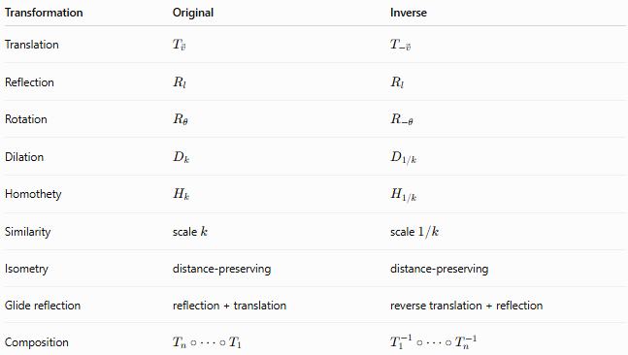
Transformation | Original | Inverse
Translation | $$T_{\vec{v}}$$ | $$T_{-\vec{v}}$$
Reflection | $$R_{l}$$ | $$R_{l}$$
Rotation | $$R_{θ}$$ | $$R_{-θ}$$
Dilation | $$D_{k}$$ | $$D_{1/k}$$
Homothety | $$H_{k}$$ | $$H_{1/k}$$
Similarity | scale $k$ | scale $1/k$
Isometry | distance-preserving | distance-preserving
Glide reflection | reflection + translation | reverse translation + reflection
Composition | $$T_{n}∘⋯∘T_{1}$$ | $$T_{1}^{-1}∘⋯∘T_{n}^{-1}$$

Classification Summary
# Source: AI Source: Provided by: [Data Path: Persons Table -> ID Column: 1, Name_En Column: Motasem Essam] -> From: [ChatGPT] on [7/25/2026]
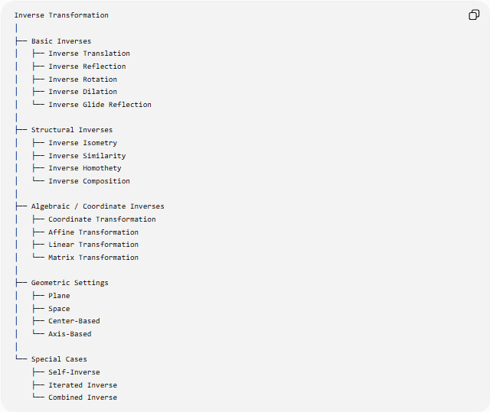
Inverse Transformation
│
├── Basic Inverses
│ ├── Inverse Translation
│ ├── Inverse Reflection
│ ├── Inverse Rotation
│ ├── Inverse Dilation
│ └── Inverse Glide Reflection
│
├── Structural Inverses
│ ├── Inverse Isometry
│ ├── Inverse Similarity
│ ├── Inverse Homothety
│ └── Inverse Composition
│
├── Algebraic / Coordinate Inverses
│ ├── Coordinate Transformation
│ ├── Affine Transformation
│ ├── Linear Transformation
│ └── Matrix Transformation
│
├── Geometric Settings
│ ├── Plane
│ ├── Space
│ ├── Center-Based
│ └── Axis-Based
│
└── Special Cases
├── Self-Inverse
├── Iterated Inverse
└── Combined Inverse

Key Formulas
# Source: AI Source: Provided by: [Data Path: Persons Table -> ID Column: 1, Name_En Column: Motasem Essam] -> From: [ChatGPT] on [7/25/2026]
General
$$\boxed{T^{-1}\left(T\left(P\right)\right)=P} \\ \boxed{T\left(T^{-1}\left(P\right)\right)=P}$$
Translation
$$T_{\vec{v}}^{-1}=T_{-\vec{v}}$$
Reflection
$$R_{l}^{-1}=R_{l}$$
Rotation
$$R_{θ}^{-1}=R_{-θ}$$
Dilation
$$D_{k}^{-1}=D_{\frac{1}{k}} \\ k≠0$$
Composition
$$\boxed{{\left(T_{2}∘T_{1}\right)}^{-1}=T_{1}^{-1}∘T_{2}^{-1}}$$
Matrix Transformation
$$T\left(x\right)=Ax \\ \boxed{T^{-1}\left(x\right)=A^{-1}x}$$
when:
$$det⁡\left(A\right)≠0$$
Affine Transformation
$$T\left(x\right)=Ax+b \\ \boxed{T^{-1}\left(x\right)=A^{-1}\left(x-b\right)}$$

Key Points
# Source: AI Source: Provided by: [Data Path: Persons Table -> ID Column: 1, Name_En Column: Motasem Essam] -> From: [ChatGPT] on [7/25/2026]
- An inverse transformation reverses another transformation.
- It is written $T^{-1}$.
- The fundamental relationship is:
$$T^{-1}∘T=I$$
- Reflection is self-inverse.
- A rotation by $θ$is reversed by a rotation by $-θ$.
- A dilation with scale factor $k$is reversed by scale factor $1/k$.
- A translation by vector $\vec{v}$is reversed by translation by $-\vec{v}$.
- The inverse of a composition is obtained by reversing the order and inverting each transformation.
- An inverse exists only when the transformation is invertible on the relevant domain.
- The inverse of an isometry is an isometry.
- The inverse of a similarity transformation is another similarity transformation.
- A transformation can be its own inverse when:
$$T^{2}=I$$
- The inverse transformation should not be confused with the converse of a geometric statement.

Conclusion
# Source: AI Source: Provided by: [Data Path: Persons Table -> ID Column: 1, Name_En Column: Motasem Essam] -> From: [ChatGPT] on [7/25/2026]
An Inverse Transformation is the transformation that exactly undoes another transformation. It provides a systematic way to recover the original geometric figure from its transformed image. The fundamental idea is:
$$\boxed{\text{Original Figure}\underset{→}{T}\text{Transformed Figure}\underset{→}{T^{-1}}\text{Original Figure}}$$
Thus, inverse transformations connect all major transformation types—translations, reflections, rotations, dilations, glide reflections, isometries, similarities, and compositions—through the common principle of reversing a geometric mapping.

